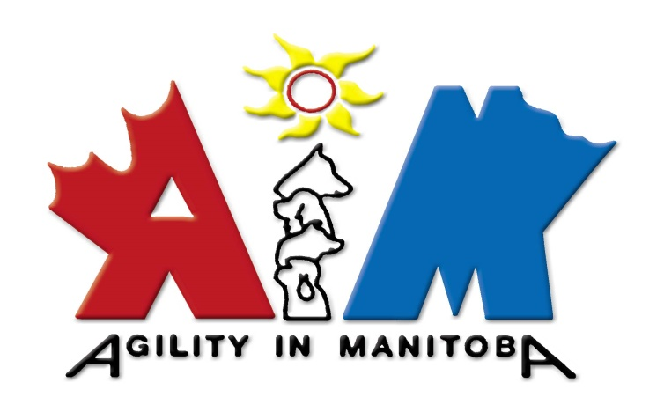

IS PLEASED TO PRESENT

Three Day Seminar

With

Aaron Froude from New Brunswick
April 19, to April 21, 2024

Agil-Tracks Training Building
5231 Henderson Highway
Narol, Manitoba

Aaron and his partner Jo operate FlatOut Dogs in Woodside, New Brunswick. https://www.flatoutdogs.com
Aaron teaches regularly for Shape UP Dogs and this is what Jessica Patterson had to say about him.

“Aaron is very kind, has a keen eye, gives detailed feedback, gets people moving and has great handling suggestions. He teaches for us regularly and is very compatible with our teaching/handling style. Where we might focus a bit more on teaching/training skills, Aaron focuses just a bit more on handling, although he definitely also teaches skills. I highly recommend him for a seminar.”

Seminar will open Feb. 01/23 and close
when all working spots have been filled.

Please fill out the Registration, and General Agreement and send it back to me by either email or snail mail on Feb. 01 2023. E-transfers can be done when the working /auditing spot has been confirmed. I will pass the link and password on at that time. If you prefer to send a cheque that is also fine, please send it to the address indicated below.
Please make sure your 2024 AIM Membership is paid if you are registering as an AIM member with the reduced rate.

Seminar Information:
Participants will be scheduled with dogs of similar skill levels and the description below might be adjusted depending on interest of participants. Please fill out the level your dog is trained at right now or highest Standard Agility Title achieved.

Day One:
The focus of the first day will either be for Young Dogs or Novice Dogs - depending on Interest.

Day Two:
Will be for Experienced Novice, Advanced or Master Teams – again, it will depend on interest of participants.

Day Three:
The emphasis on day three will be on Experienced Master Teams. The focus of this session can be on higher level Master skills –depending on interest.

Registration Forms:
Cheques payable to AIM
Snail mail to: B. Hunter
24 Lorne Hill PL
Sunnyside, MB, R5R 0A8
Email: klondike@mymts.net

Name: ________________________________________________

City: _________________________________________________

Province: _______ Postal Code: _______________________

Phone: Home: _______ ______ Cell: _____________________

Email: ________________________________________________

Dog’s Name: ___________________________________________

*Level the dog is trained at right now or Highest Standard Agility Title achieved: ____________________________________________________

Breed: _______________________Age: _____________________

Jump Height at the seminar: 4___ 8___ 12___ 16___ 20___ 24___

Cost of a working spot $ 365.00 for AIM Members,
$ 400.00 for Non-AIM Members,
(If there are working spots available)

All working spots for this seminar include unlimited auditing.

Auditing $ 150.00 per day for AIM Members
$ 175.00 per day for NON – AIM Members

Please note: Important considerations:
- All Manitoba Health Regulations will be enforced.
- Wearing of Masks is optional at this point; if that changes you will be notified before the seminar.
- All participants will have to rake for each other.

AIM - General Agreement

Please print, sign and include this document with your entry.

Not Valid Unless Dated and Signed.

In consideration of the acceptance of this entry and the holding of the event and the opportunity to have the dog participate.

I/We agree to hold the organizing committee, the organization which it represents, Agility in Manitoba including its members, officers, and directors, presenter of the seminar, owner of the premises upon which the event is being held and their employees, harmless from any claims for loss or injury which may be alleged to have been caused directly or indirectly to any persons or thing by the act of this dog while in or upon the event premises or grounds or near entrances thereto, and I/We personally assume all responsibility and liability for any such claim.

I/We further agree to hold the aforementioned parties harmless from claims of this dog by disappearance, theft, death or otherwise from any damage or injury to the dog, whether such loss, disappearance, theft, death or otherwise be caused or alleged to be caused by negligence of the parties aforementioned, or by negligence of any person, or any cause or causes.

I/We hereby assume the sole responsibility for and agree to indemnify and save the aforementioned parties
harmless from any and all loss and expense (including legal fees) by reason of the liability imposed by law upon any of the aforementioned parties for damage caused by bodily injuries, including death at any time resulting thereof, sustained by any person or persons, including myself/ourselves or on account of damage to property, arising out of or in consequence of my/our participation in this event, however such injuries, death, or damage to property may be caused and whatever or not the same may have been alleged to have been caused by negligence of the aforementioned parties or any of their employees or agents or any other persons.

Name: Print clearly _________________

Signed: ___________________________

Date: _______________________________

